**VPC Peering Lab – 3 of 3**

Goto “N.Virginia”region,

Goto VPC Dashboard,

Click “Peering connections”

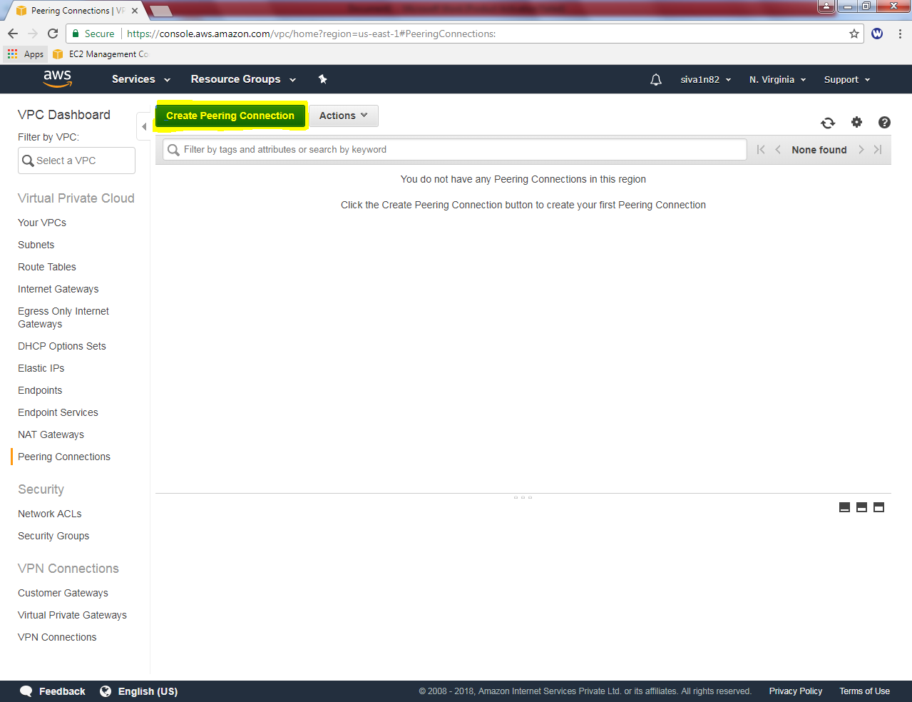

Click “Create Peering Connections”.

In peering Connection,

Peering Connection name tag: VPC Peer Ohio_NVG

VPC Requestor : VPC_North Virginia

Account : MyAccount

Region : Another Region

Select: Ohio

VPC Accepter : VPC_Ohio (type VPC ID of VPC Ohio).

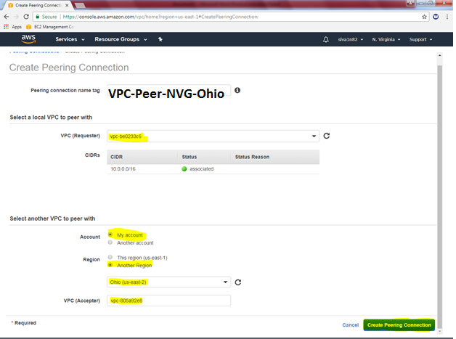

Click “Create Peering Connection”.

VPC Peering Created successfully.

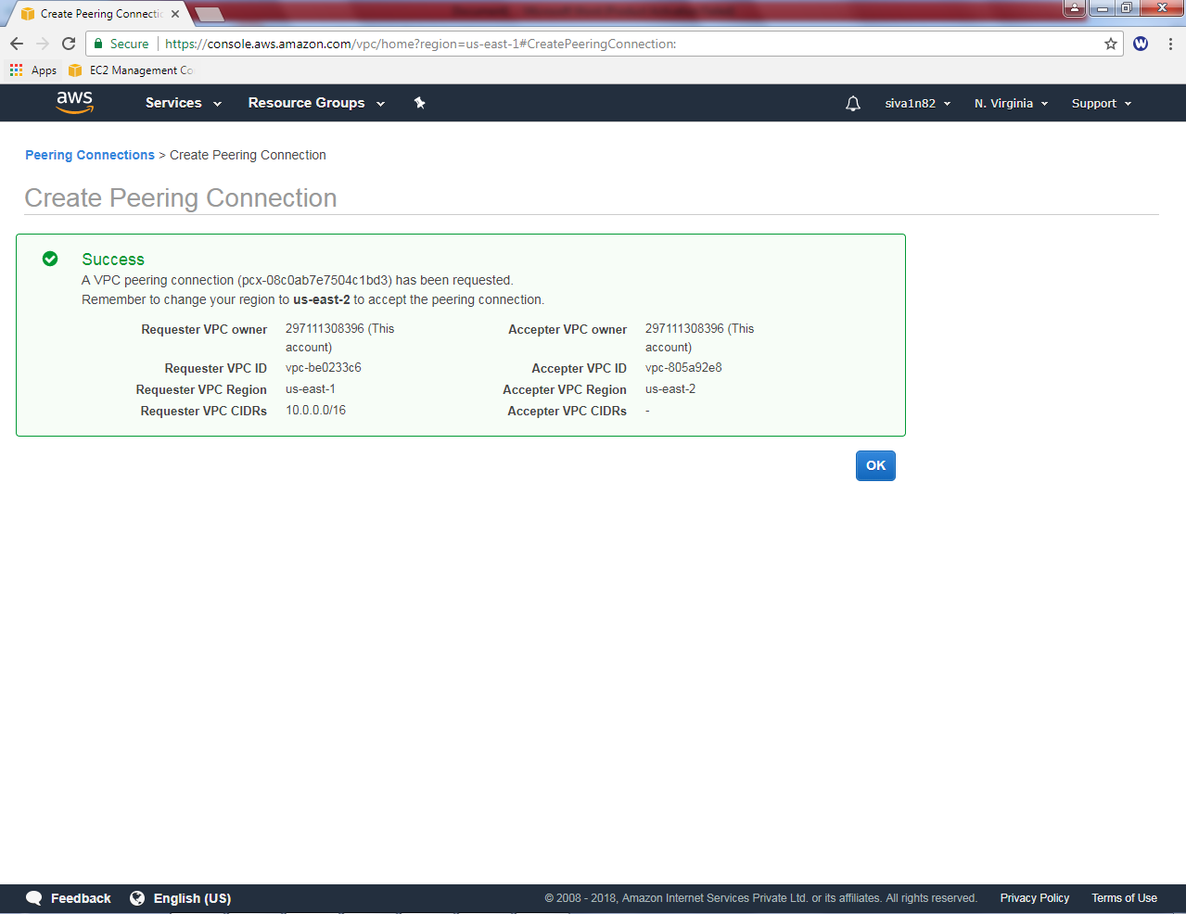

Go to Ohio region, Peering connections

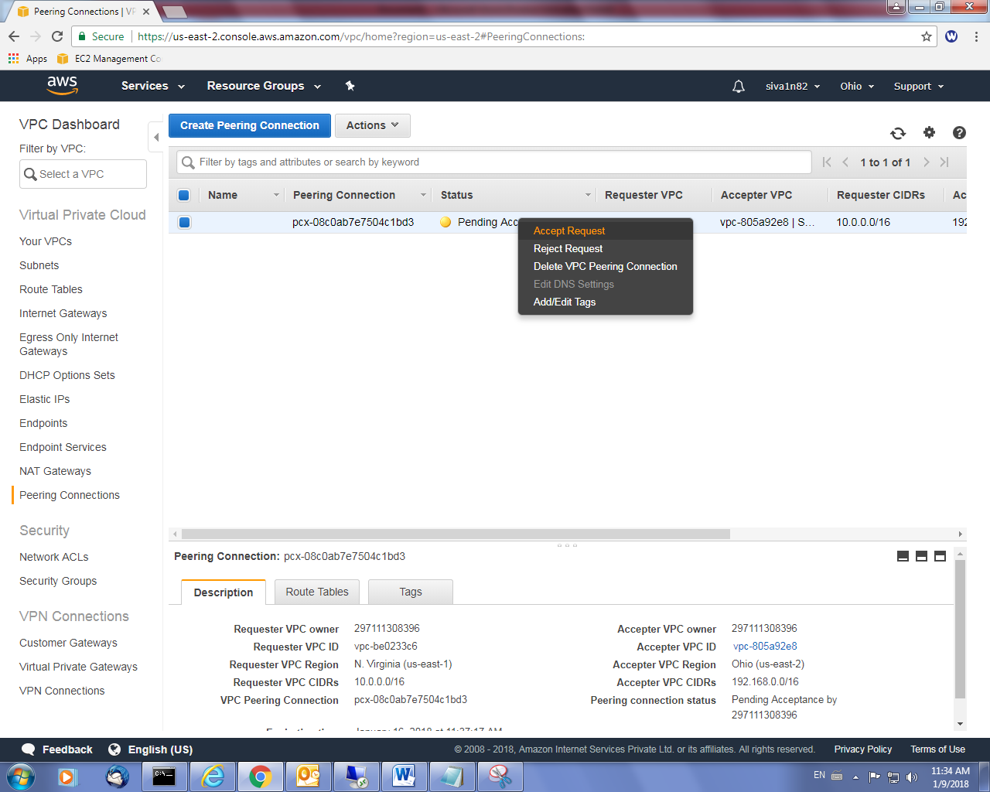

Click “Accept Request”.

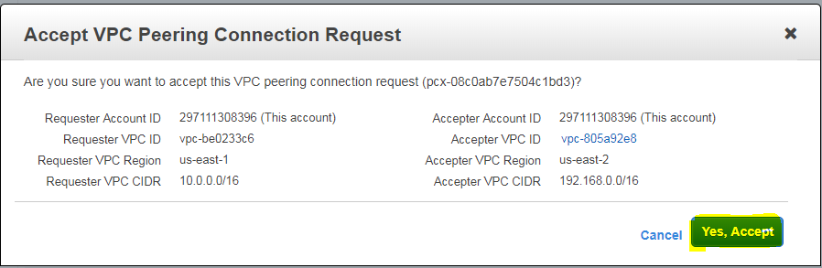

Click “Yes Acccept”.

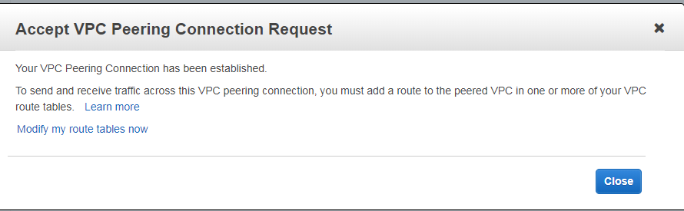

VPC Status of N.Virginia is active.

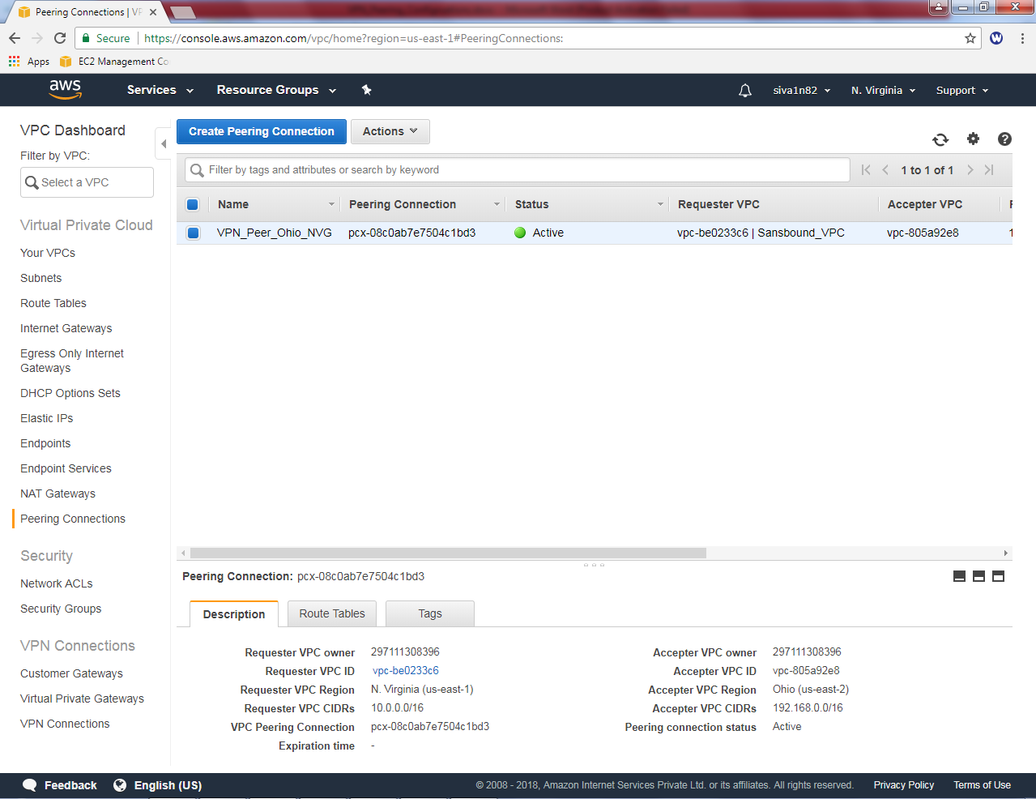

VPC Status of Ohiio is active.

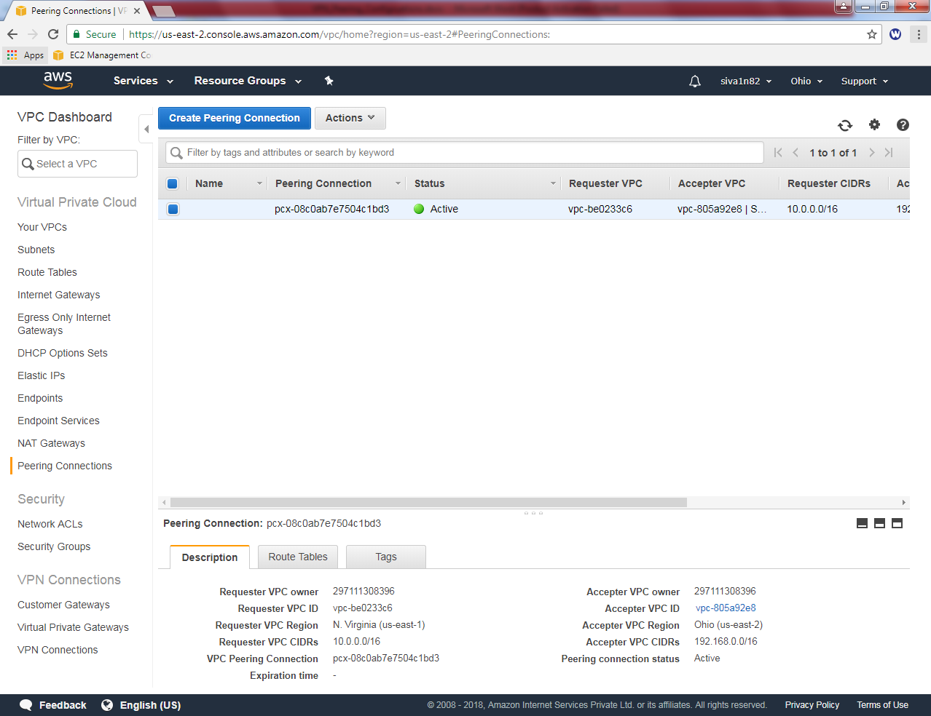

If you try to connect the LAN Segment through RDP will not connect. Because we need to add route table for Ohio subnet in N.Virginia public route table.

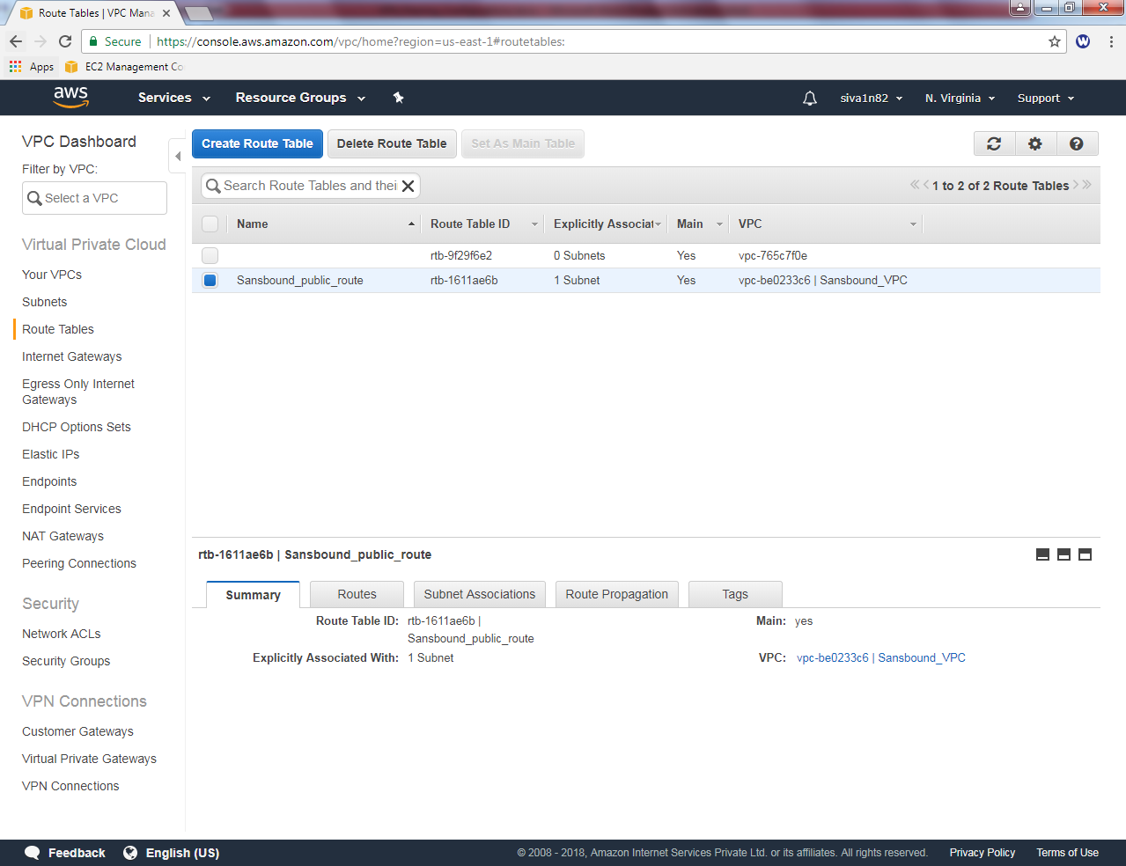

In Sansbound public route, select route and click “Edit”.

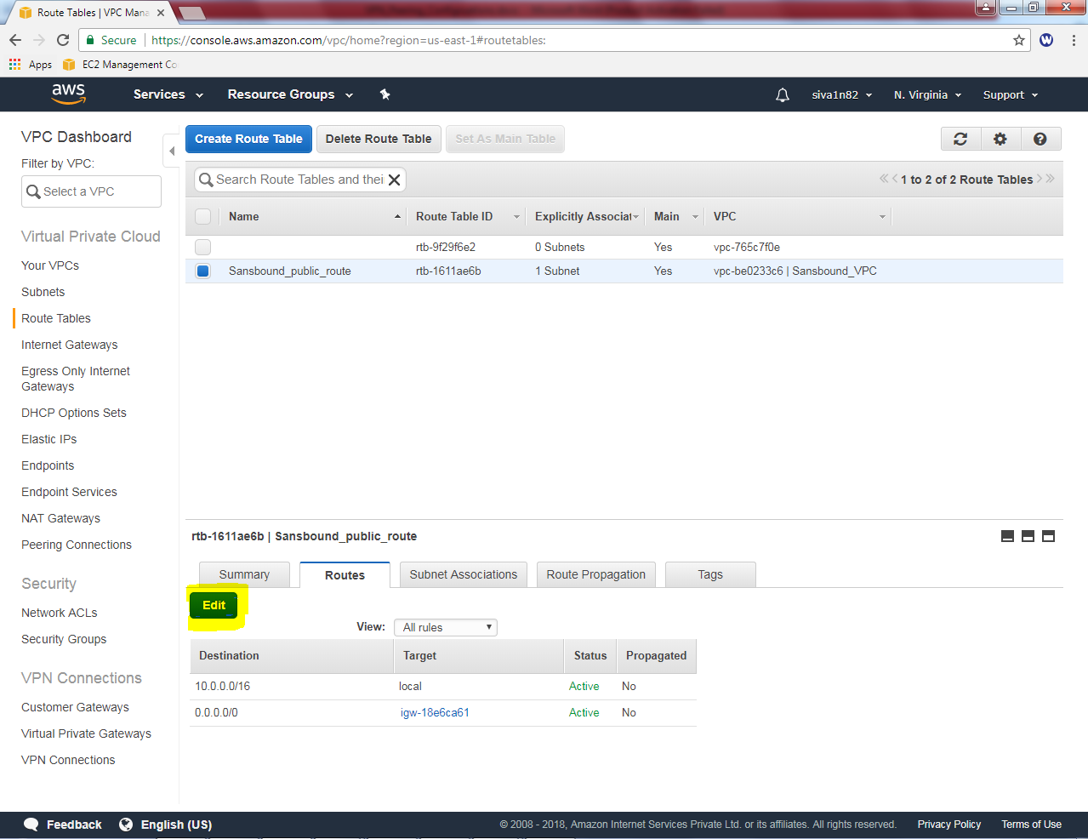

Click “Add another route” and type 192.168.0.0/16 ohio subnet and select **“pcx-*” as target.**

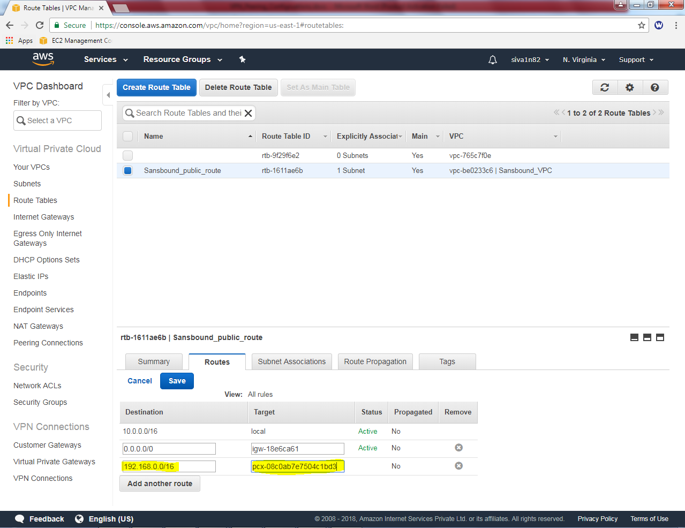

Then click save.

Goto ohio region,

Goto VPC Dashboard,

Click route table, then select “Sansbound_Ohio_public”

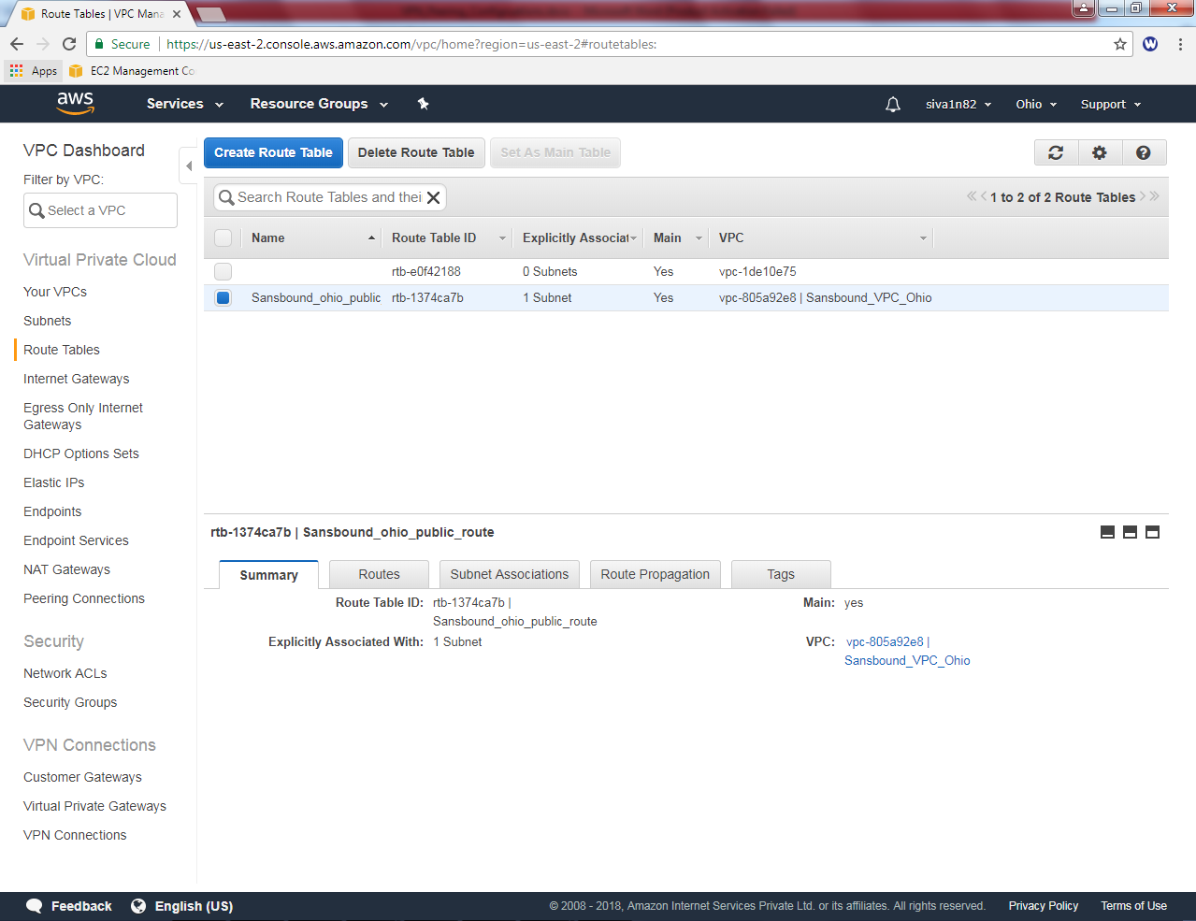

In Sansbound_ohio_public routing table, route option and then click “Edit”

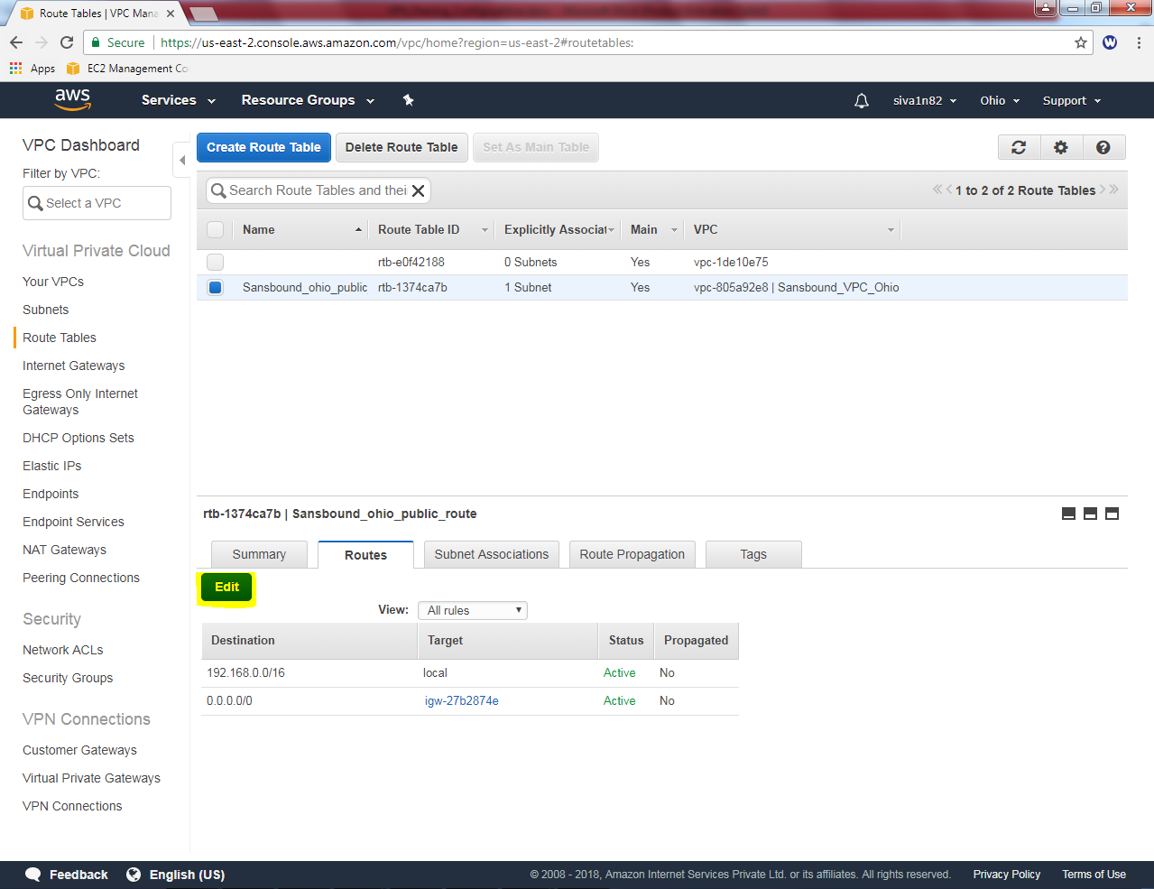

Click “Add another route”

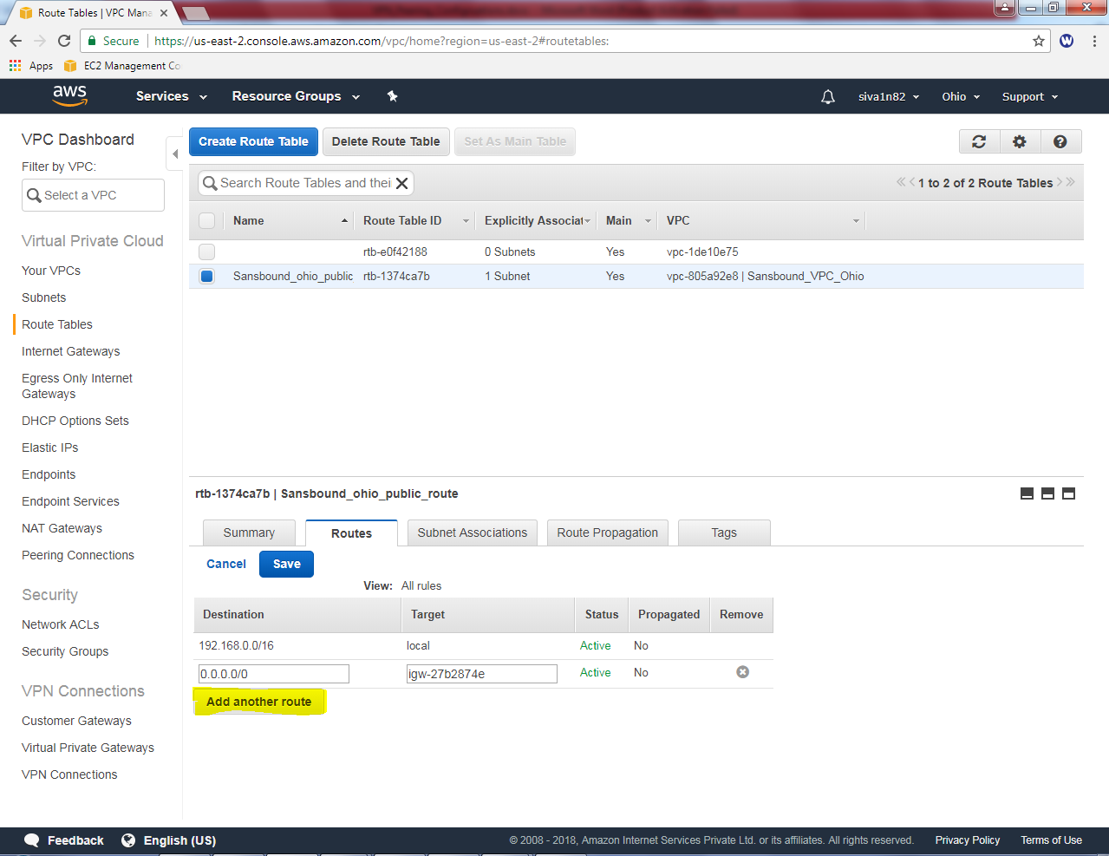

In Sansbound_Ohio_public_route table type N.Virginia subnet 10.0.0.0/16 and select target as **“pcx-*”**

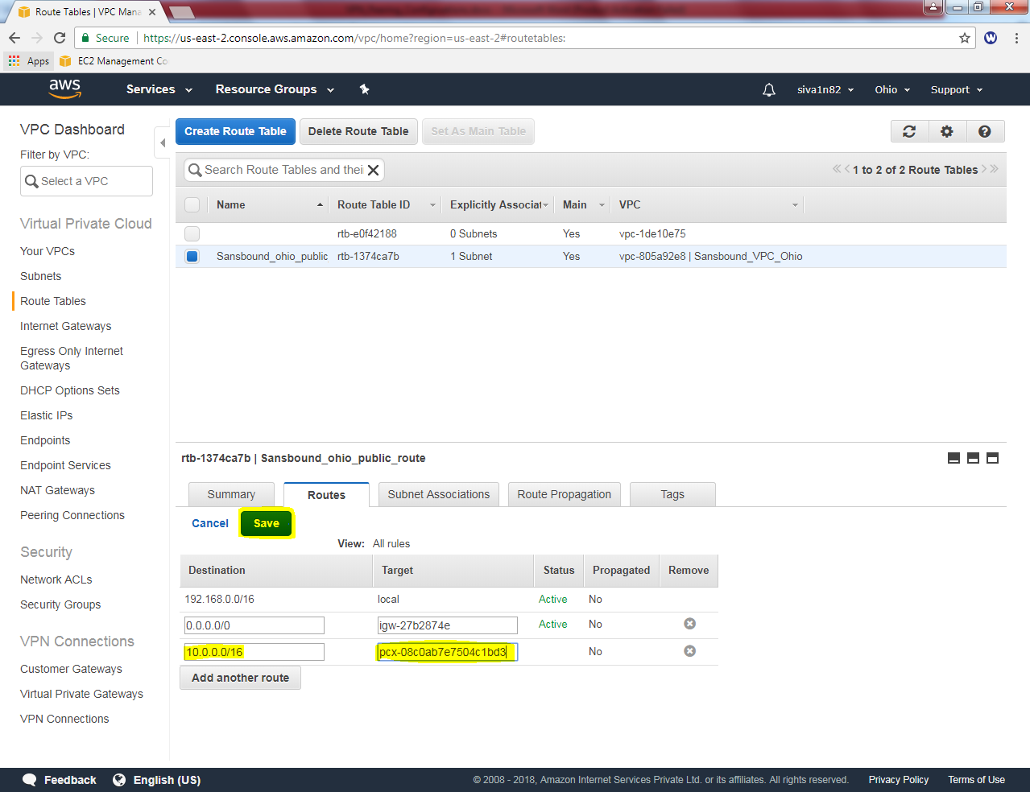

Goto North virgnia, click EC2 service to get login credentials.

Actions 🡪 Connect

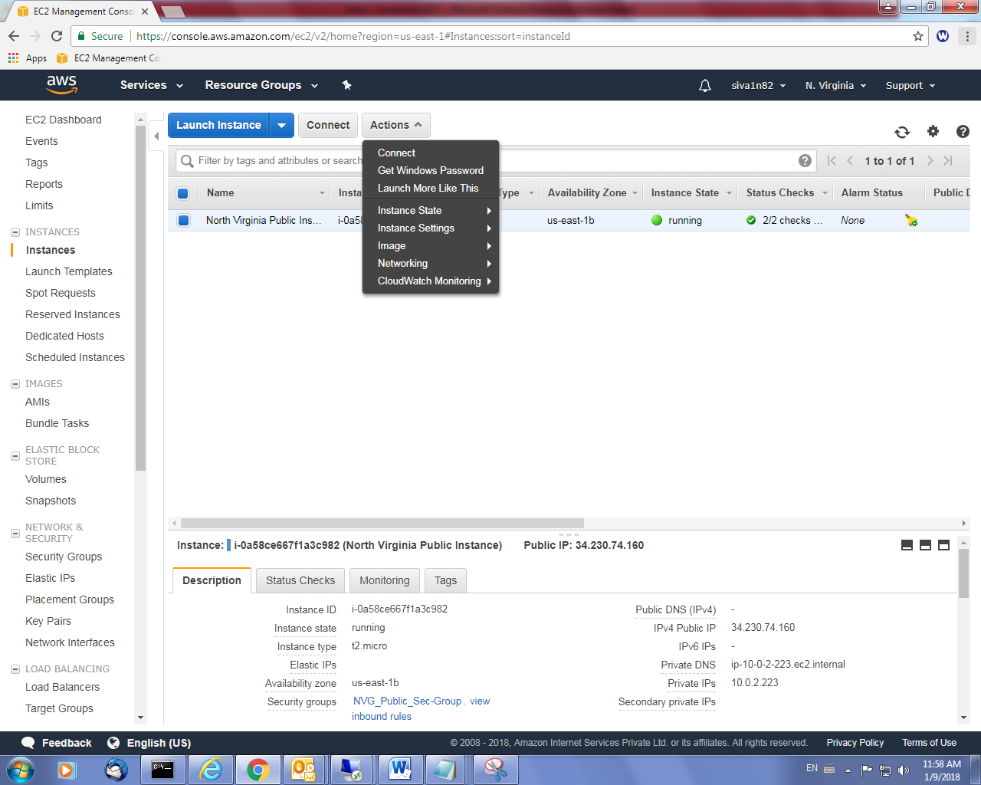

Click get password.

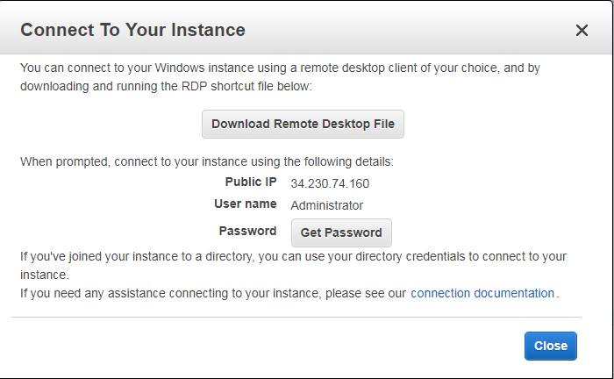

Choose the *.pem file and decrypt the password.

Goto ohio region, select the instance and Actions 🡪 Connect.

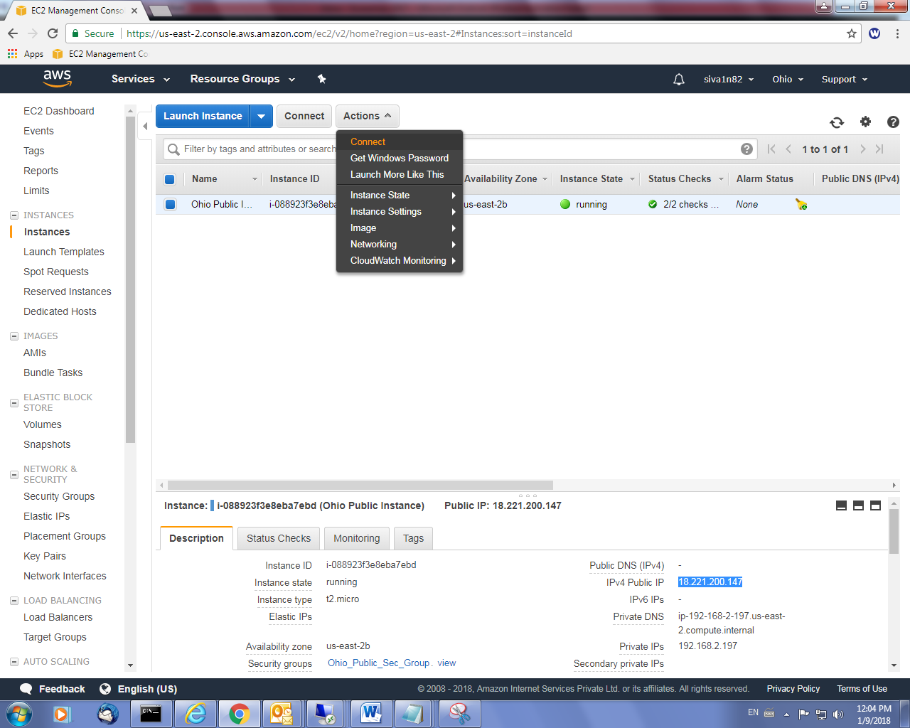

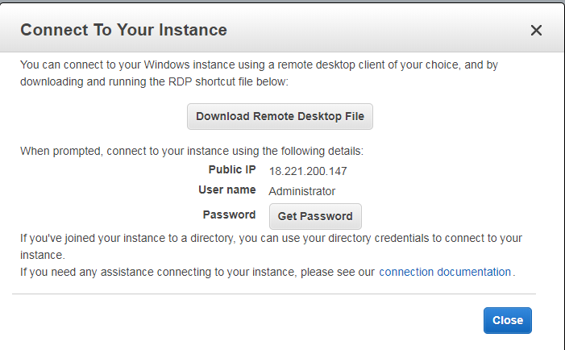

Choose the *.pem file and decrypt the password.

Try to connect RDP of Ohio subnet from N.Virgnia.

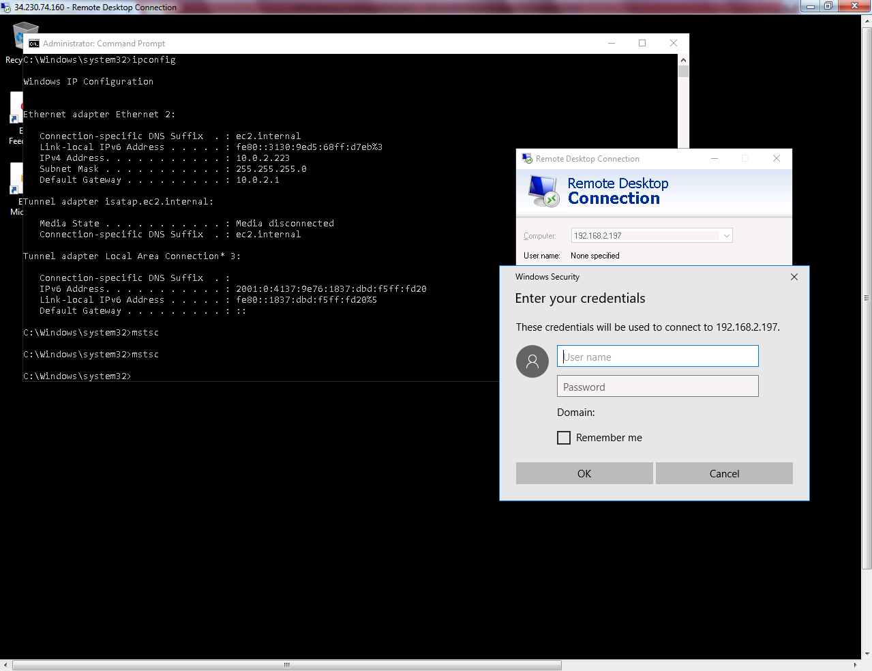

Try to ping 10.0.2.223 (N.Virginia) subnet from Ohio subnet 192.168.2.0/24. But we are unable to ping due ICMP was not permitted in Security Group of North Virginia.

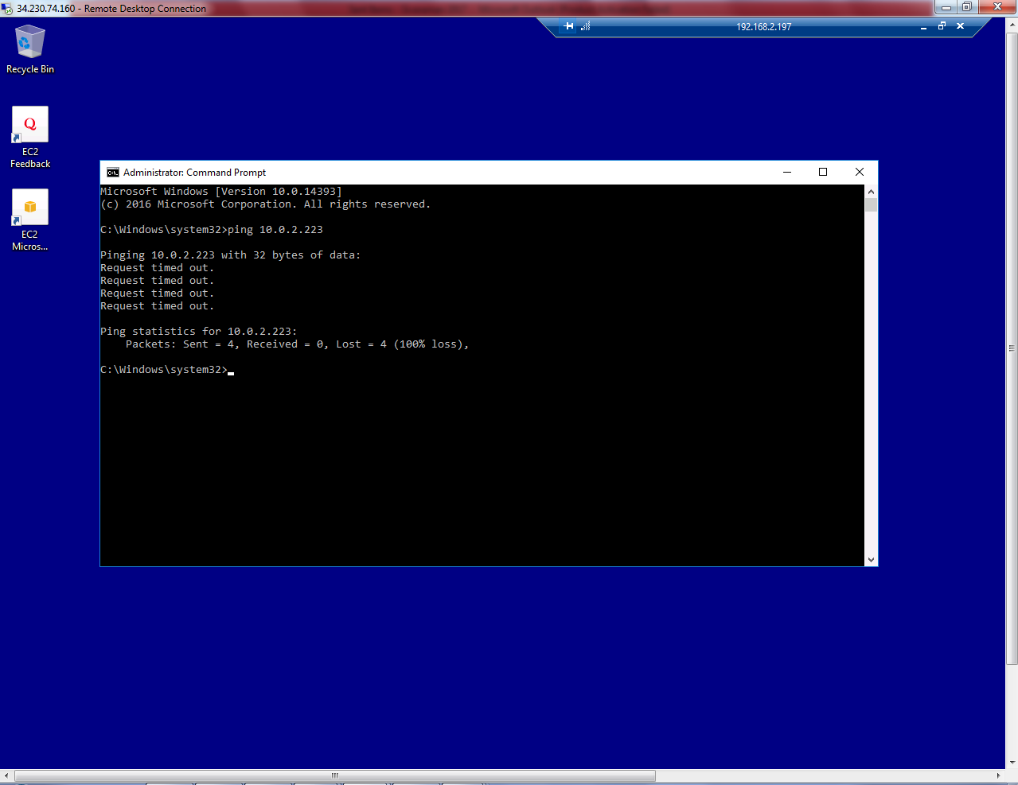

Try to ping 192.168.2.197 subnet from North Virginia subnet 10.0.2.0/24. But we are unable to ping due ICMP was not permitted in Security Group of Ohio.

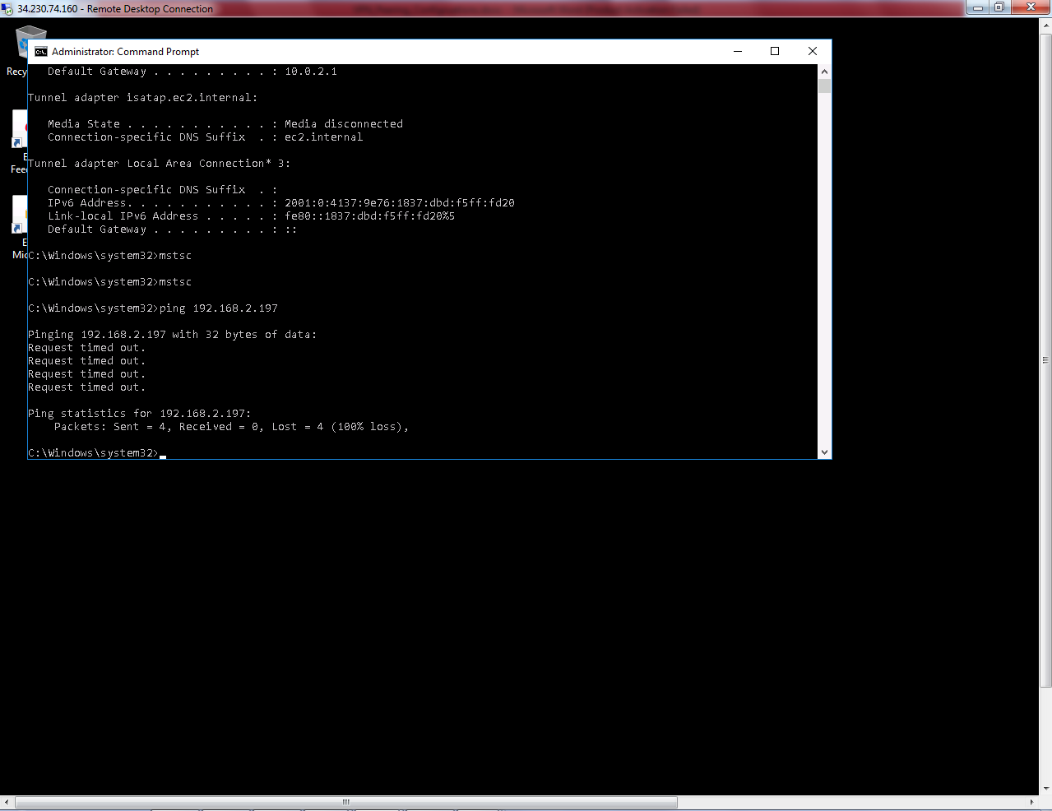

In Security Group, select inbound rule, click “Edit”

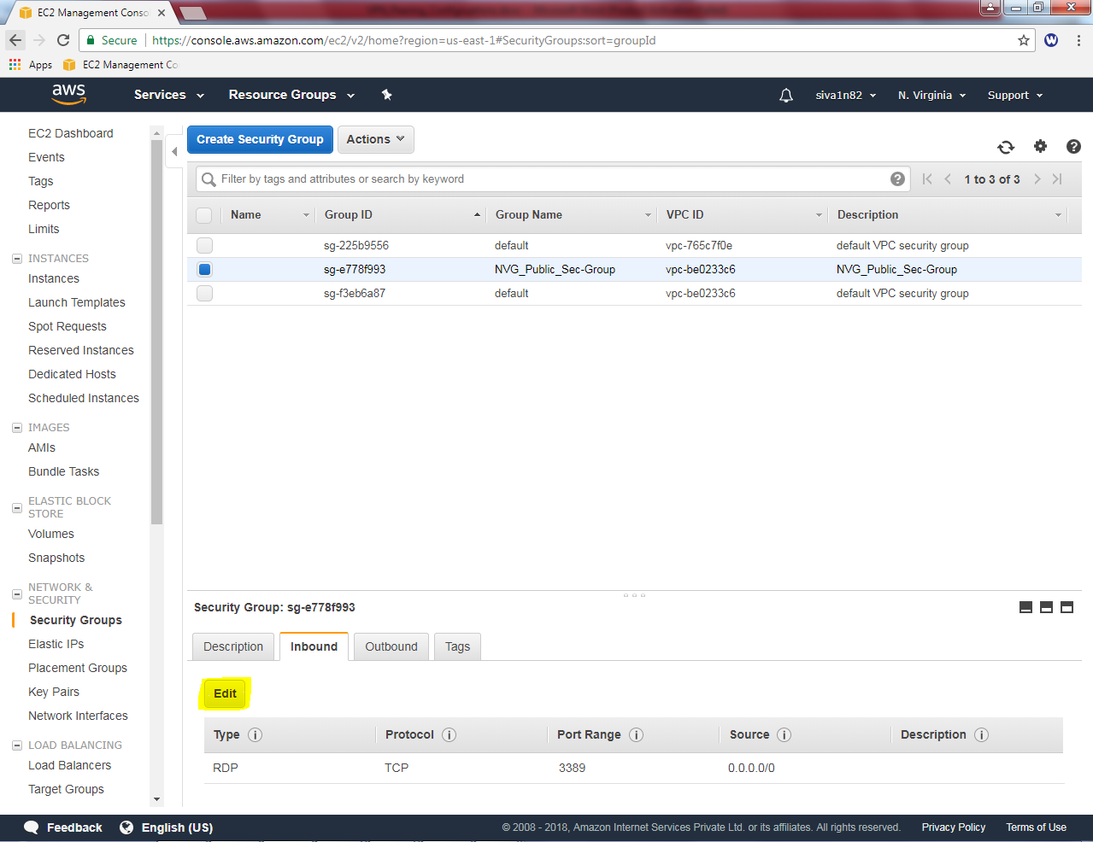

Click “Ädd rule” Select Custom ICMP Echo Request 0.0.0.0/0

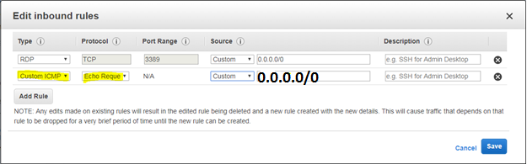

In Ohio region, ohio public security group,

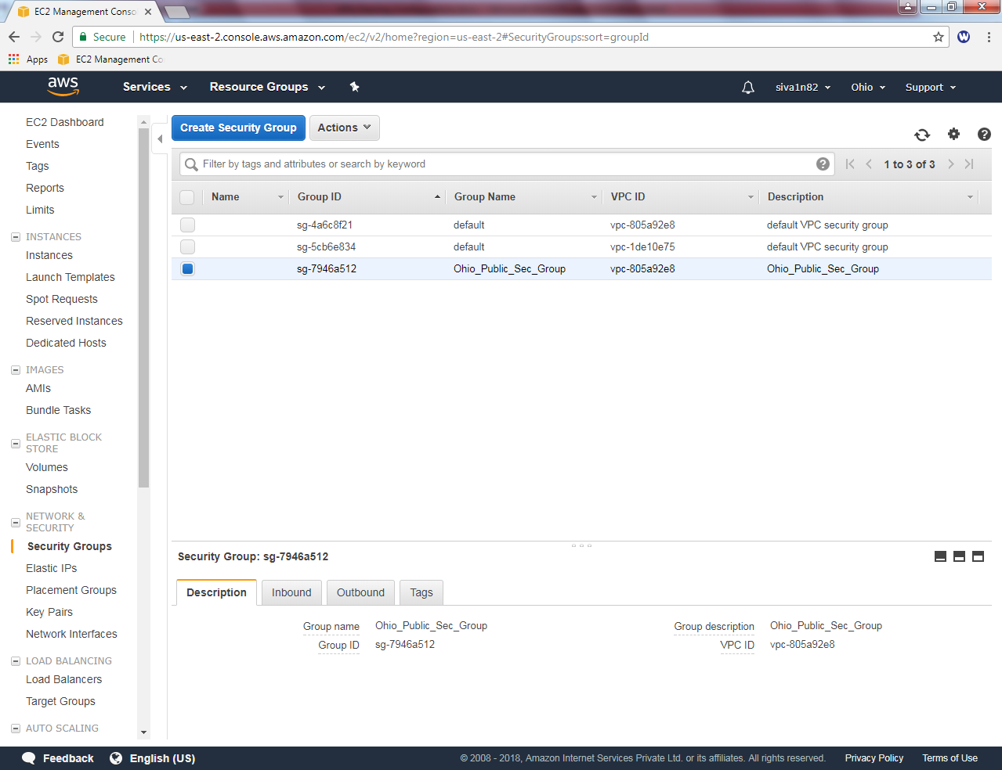

Click “Inbound” rule, then click “Edit”.

Click “Ädd rule” Select Custom ICMP Echo Request 0.0.0.0/0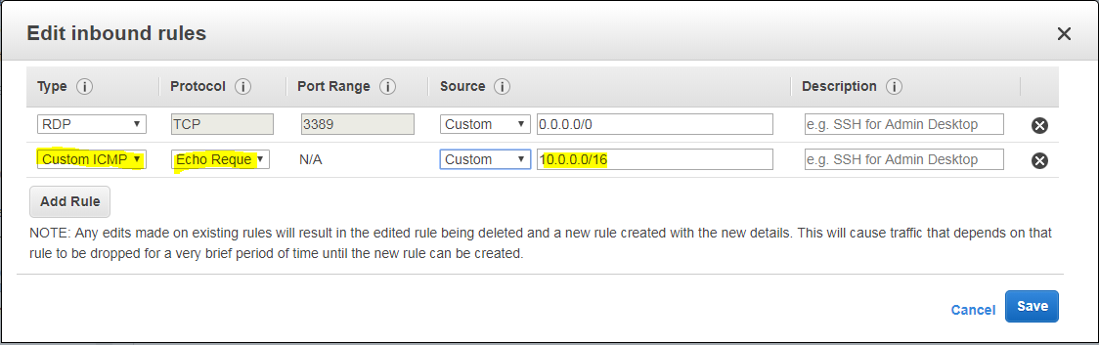

Then try to ping LAN segment IP will not ping due to firewall is turned on in Windows Server 2016. We need to **Turn off on both Servers (North Virginia and Ohio).**

**In windows 2016 server, Right click start menu click command prompt and type firewall.cpl to get windows firewall. Click “Turn windows firewall on or off”.**

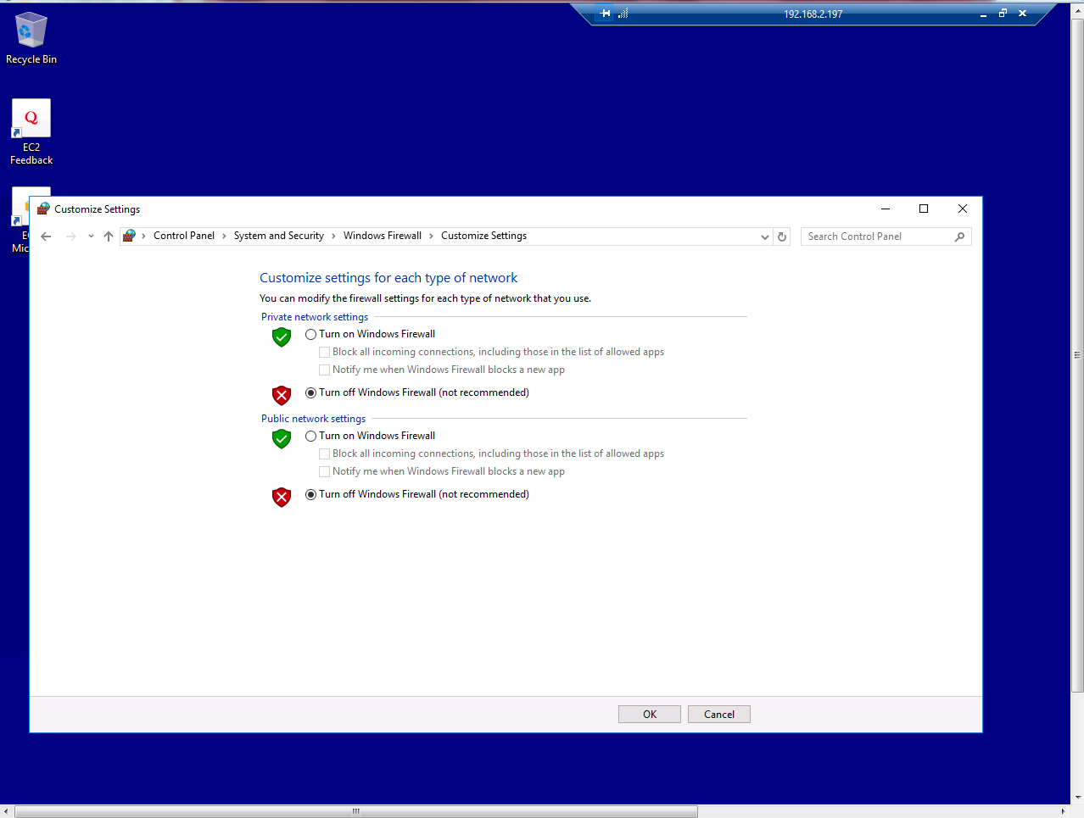

Now We are able ping 10.0.2.223 North Virginia host from Ohio subnet 192.168.2.0/24

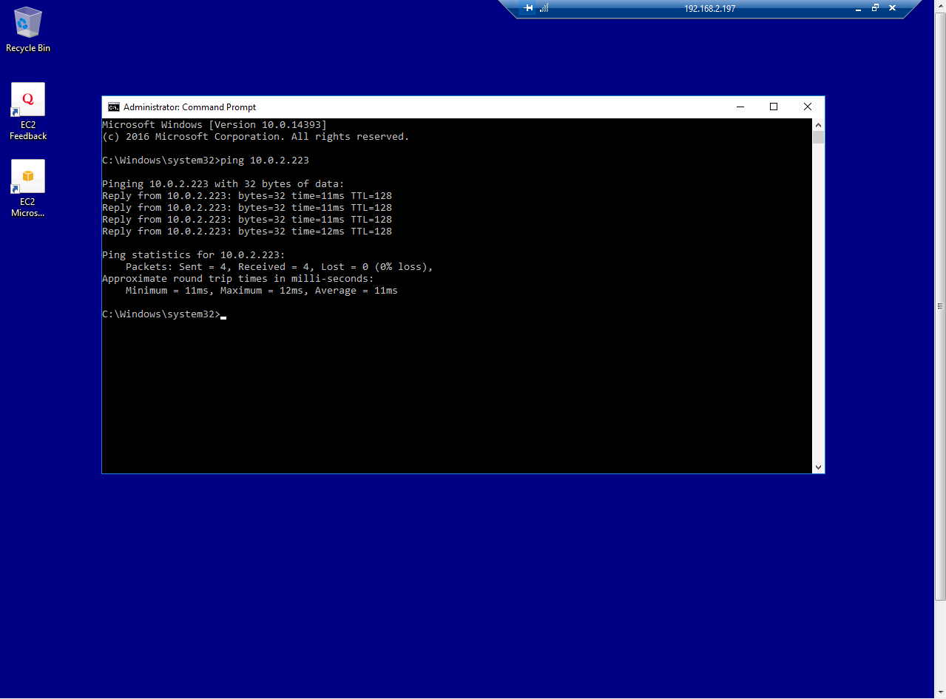

Now We are able ping 192.168.2.197 Ohio host from North Virginia subnet 10.0.2.0/24 subnet.

